IBM Phase 5

Media Streaming With IBM Cloud video Streaming

This is Last Phase of our project Media streaming so we are going to create a virtual cinema platform with IBM cloud video streaming.

Project Objective:

The Virtual Cinema Platform aims to create an immersive online movie-watching experience that replicates the feeling of being in a traditional cinema. This project was developed in response to the increasing demand for online entertainment due to various constraints, such as the COVID-19 pandemic.

First we have to sign-in an account:

**Signing up for IBM Cloud for Video Streaming:**

1. Go to the IBM Cloud website (<https://cloud.ibm.com/>).
2. Click on "Sign Up" to create a new account if you don't already have one.
3. Fill in your information, including your email address, first name, last name, and password. Accept the terms and conditions and click "Next."
4. Provide additional information such as your phone number and company details.
5. Verify your email address by clicking on the confirmation link sent to your email.
6. Once your account is set up, log in to the IBM Cloud Dashboard.
7. In the dashboard, go to the "Create Resource" option and search for "Video Streaming."
8. Select the "Video Streaming" service and follow the prompts to create your instance.

**UI, Video Upload Process,Streaming Integration Steps:**

1.Sign in to your IBM Cloud Account.

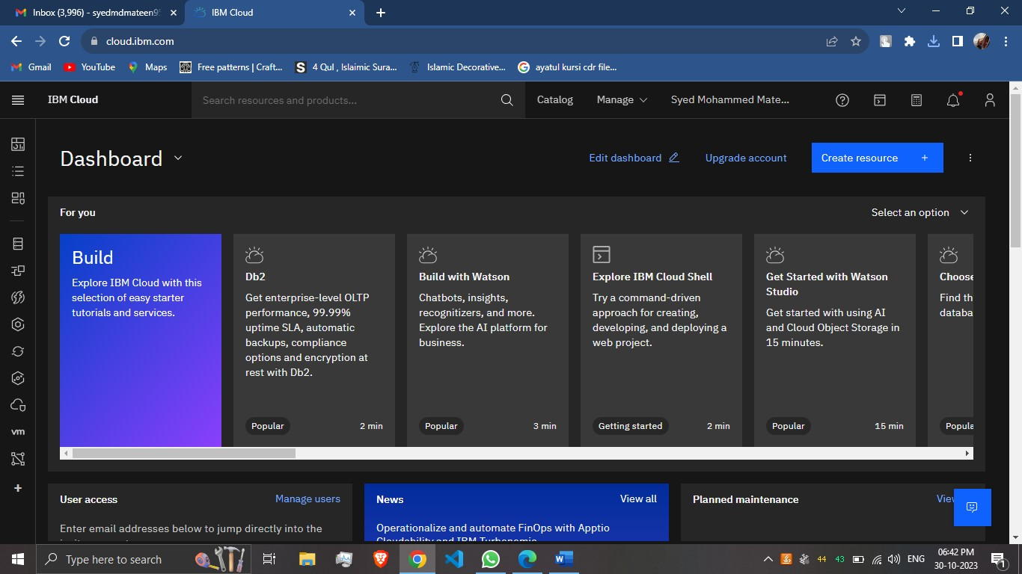

2.Access IBM Account and click “Catalog” option in IBM Cloud dashboard , click “Object storage” service provided by IBM.

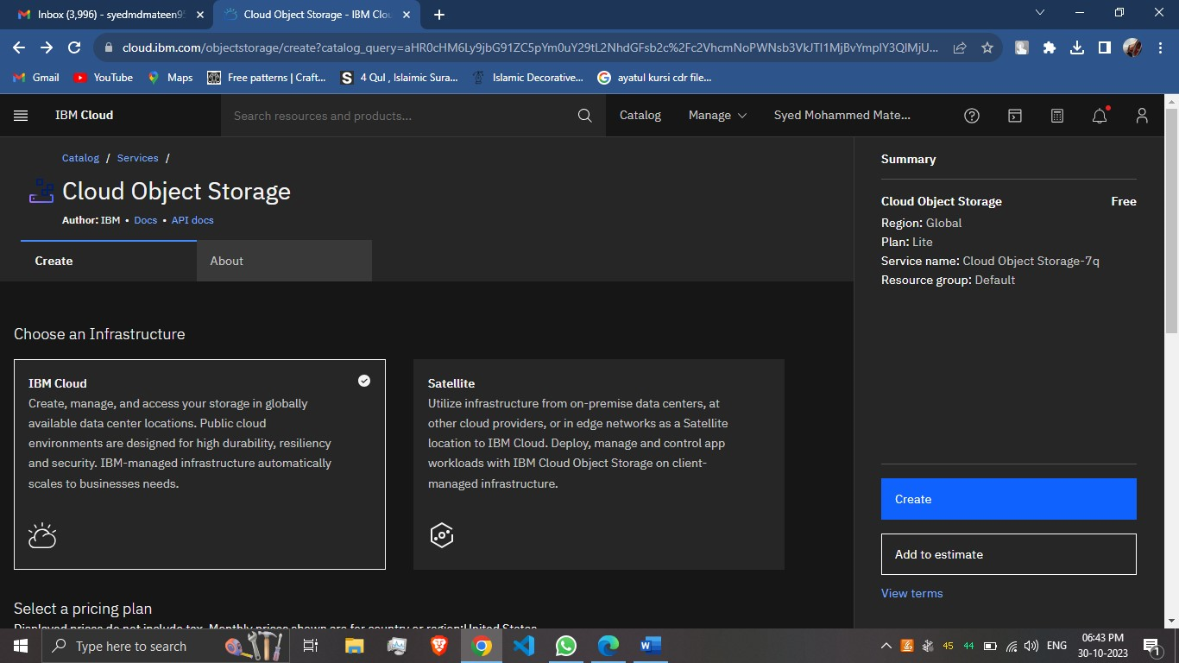

3.Create a Bucket with Unique Bucket name

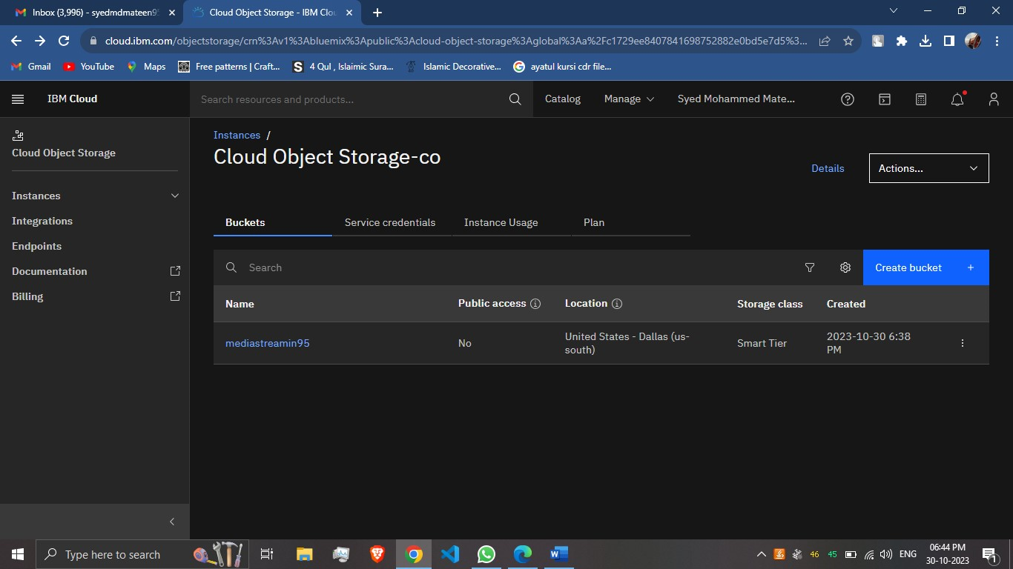

4.Upload Media or Video that you want to share with your friends and family



5.Video is uploaded successfully.

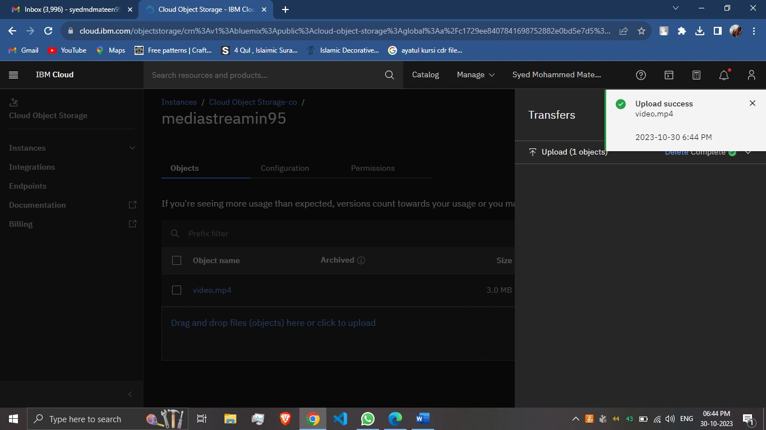

6.Create an access group with the members you want to access your media,This has to be controlled to ensure security.Access is granted to Members or group of people.

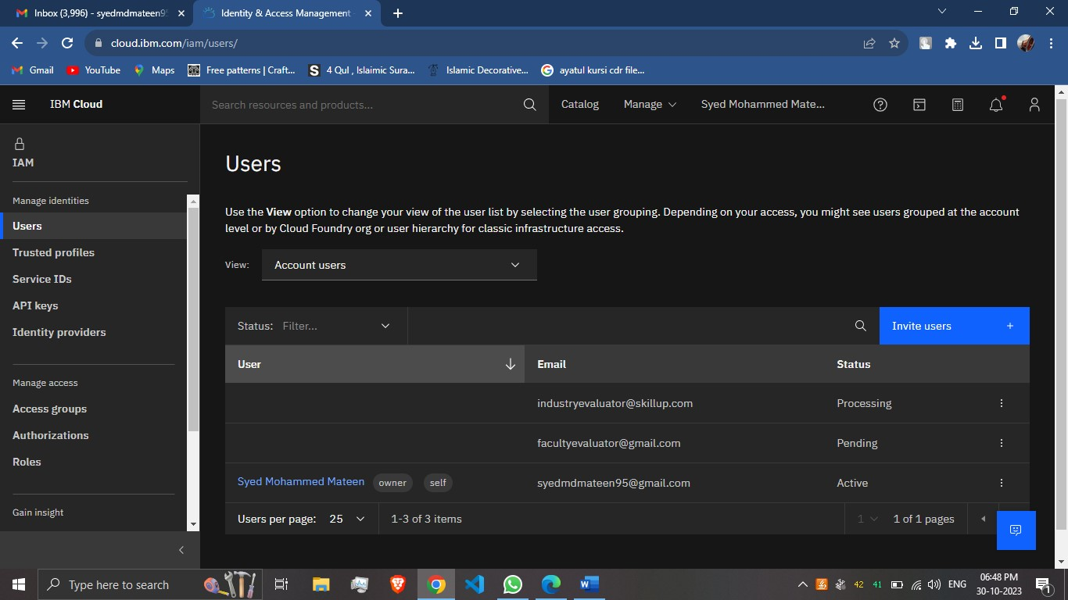

7.Now Enjoy watching the videos by downloading or access it online with your friends or members you want to share

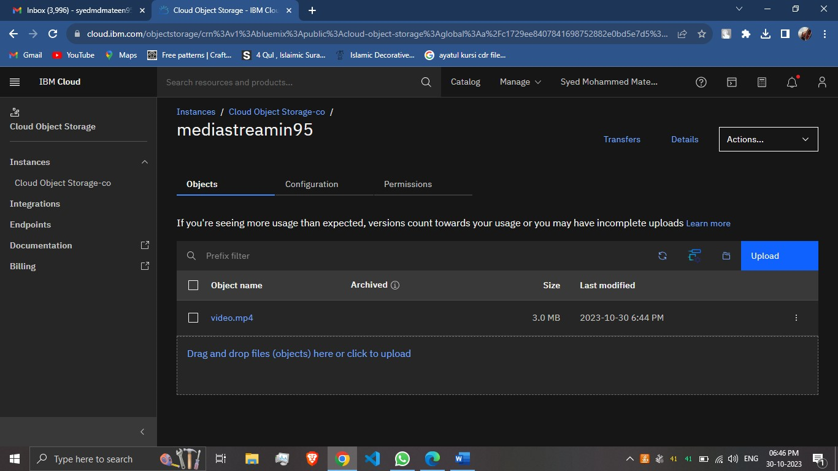

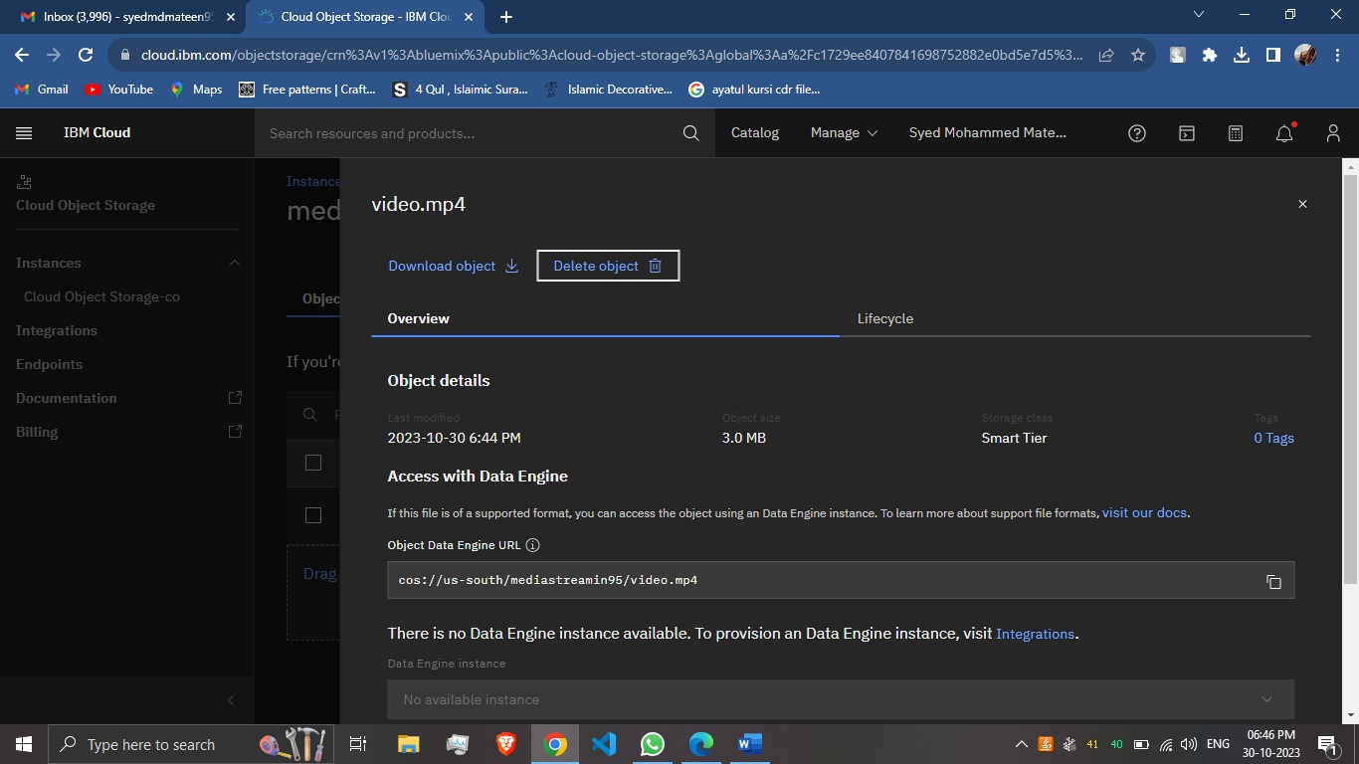

Development Phases:

1. **Front-End Development:** Designing the user interface, focusing on a cinema-like aesthetic with dark themes and large screens.
2. **Back-End Development:** Building the infrastructure to handle user accounts, video uploads, and streaming services with the help of IBM Cloud Services
3. **Video Upload Process:** Creating an easy-to-use video upload feature for filmmakers, including video quality checks and formatting guidelines. This can be done with the help of IBM Cloud Video Streaming Service.
4. **Streaming Integration:** Integrating a high-quality video streaming service to ensure smooth playback with minimal buffering.
5. **User Accounts:** Implementing user registration, profile management, and payment processing for premium content. IBM allows users to access the media with their services.
6. **Content Curation:** Offering a selection of curated movies and live events, with options for users to host their private screenings.

Platforms Features:

1. **High-Quality Video Streaming**:
   * Utilize IBM Cloud Video Streaming for reliable and high-quality video playback.
2. **Content Library**:
   * Maintain a catalog of movies and content available for streaming.
3. **User Profiles**:
   * Allow users to create and manage their profiles, customize avatars, and track viewing history.
4. **Video Streaming Controls**:
   * Offer video playback controls like play, pause, rewind, fast forward, and volume adjustment.
5. **Chat and Interaction**:
   * Implement real-time chat or discussion features to enable users to interact during movie screenings. IBM allows it with their services.
6. **Security and DRM**:
   * Implement Digital Rights Management (DRM) for content protection.
   * Ensure secure user authentication and access controls.

**Seamless and Immersive Experience:**

**Realistic Cinema Setting:** Users can select their preferred seat, listen to audience reactions, and enjoy a lifelike cinema atmosphere.

**Live Events:** Virtual premieres, Q&A sessions, and director commentary to enhance the movie-watching experience.

**Accessibility:** The platform is accessible on various devices, making it easy for users to watch movies from anywhere.

The Virtual Cinema Platform is designed to offer a truly immersive and authentic movie-watching experience online, with the objective of bringing back the magic of the traditional cinema while adapting to the demands of the digital age.

Thus I will conclude our Project…

Thank You!